An End-User Guide to
MANAGE BY EXAMPLE Version 3 for Lotus Notes

We have installed a simple piece of software into your e-mail called Manage By Example (MBE). This software is designed to assist you with managing e-mail after SpamSentinel has stopped 99% of spam messages. MBE helps separate out e-mail based on your existing relationships, and your own personal preferences.

You will see the following folders have been added to your Inbox: Preferred Inbox, Other Inbox (optional), Newsletters and Manage By Example (which expands as shown below). Please read on to learn more about this new tool.

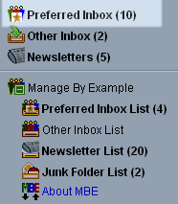 |   Preferred Inbox helps separate out email based on your existing relationships along with your own personal preferences. It replaces Inbox. From your Lotus Notes Sent Folder MBE can determine your "important contacts". MBE checks all inbound mail against the list of people in the Sent mail folder. If there is a match, MBE "promotes" the message to your Preferred Inbox. In addition, MBE places all Lotus Notes email users in your organization in your Preferred Inbox.

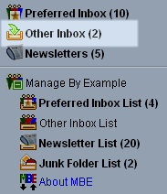 | The Other Inbox is optional and may be turned off if you do not want to check both Preferred and Other regularly and for use with Blackberry or mobile devices. The “Other Inbox” is new. If you have never emailed a sender, then they automatically show up in the "Other Inbox". These are new relationships or perhaps unwanted non-spam messages.  If you click on “About MBE”, you will see the option below to turn the option on/off.

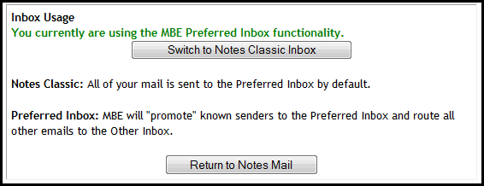
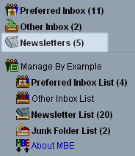 | Newsletter folder will contain messages that are determined to be Newsletters and any Newsletters that you assign to this folder by a one-time drag/drop method. This separates Newsletters from Preferred Inbox and allows you to review Newsletters in one location.

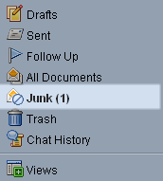 | Junk Mail will now contain “suspect” messages also known as “Spam-B” messages that SpamSentinel has determined are not spam and/or may be valid. These messages may be dragged to Preferred Inbox or Newsletter folder under the Manage by Example folder one time as your preference for future delivery. They may also be deleted if they are spam.

What if you find an email that you always want to appear in the Preferred Inbox? Drag it into the “Preferred Inbox list” folder, and MBE will always put that sender in the Preferred Inbox.
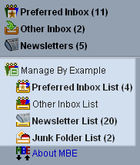 | Manage By Example  You can always change your mind later again just by dragging and dropping to a different folder.  You can override SpamSentinel or even your Sent folder by dragging a message into a different folder. Moving forward, MBE will redirect that message to that folder.  When you want to view the lists that you have made, you can review the choices by clicking on the "Lists" in the Manage By Example tab.
MBE Icons: These icons appear in the MBE views and share information with the user about each message. Specifically, it explains how this message found its way to this particular folder:
Preferred Sender (based on user preference)
Internal Mail (Notes mail) This is always Preferred mail.
Preferred Sender (based on Sent Mail being found)
Sender listed in Customer database (this is a special "by request" feature)
Other Inbox (based on user preference)
Newsletter
Newsletter (based on user preference)
Junk Mail (based on SpamSentinel results)

